**Drehpunkt beim Vision System**

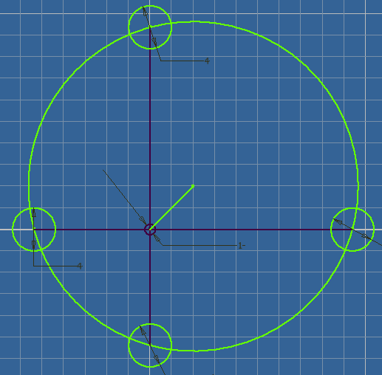Schwerpunkt [Xs,Ys] =

Xs = ( (P1x+P2x+P3x+P4x)/4) * 2 = (P1x+P2x+P3x+P4x) / 2

Ys = ( (P1y+P2y+P3y+P4y)/4) * 2 = (P1y+P2y+P3y+P4y) / 2

**Drehpunkt beim Antriebssystem**

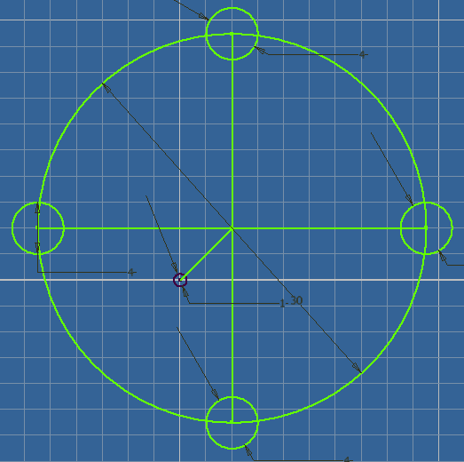Schwerpunkt [Xs,Ys] =

Xs = (P1x+P2x+P3x+P4x) / 4

Ys = (P1y+P2y+P3y+P4y) / 4